# School Based Health Center Summer Services

* **No out-of-pocket cost!**
* **Convenient on-site location!**
* **Additional resources!**

**Brookside Elementary School**

302-454-5454 option 4

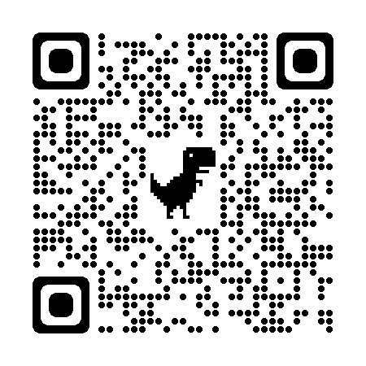

Open:

Monday-Thursday at Brookside

8:30am to 4pm

*All offices closed on July 4 and July 19.*

**Location:**

Brookside Elementary School

**Summer Services Offered:**

Medical Care

Mental Health Counseling

Community Aid Resource Support

Please contact your local

school for more information.