**PDMS FIX**

We’ve been having some issues with Internet Explorer accessing PDMS. Firefox and Chrome work with no problem (you might try one of those browsers), but this is the “fix” for Internet Explorer.

If you are unable to access PDMS due to “Reason Unknown” or “The system failed to log you in for the following reason: Unhandled login exception occurred. Please contact your system administrator”, you may need to add PDMS to your list of trusted web sites.  Please try the following:

1. Open **IE**
2. Click the Gear Icon (or select Tools) > **Internet options**
3. Click the **Security** tab
4. Click on **Trusted Sites**
5. Click the **Sites** button next to Trusted Sites

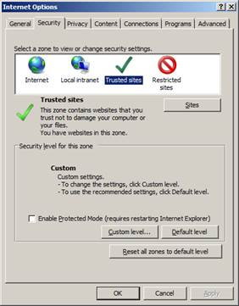

1. Enter the following URL’s in the box titled Add this website to the zone > click **Add** after each entry:

[**https://pdms.doe.k12.de.us**](https://pdms.doe.k12.de.us)

[**https://doe.k12.de.us**](https://doe.k12.de.us)

**\*.doe.k12.de.us**

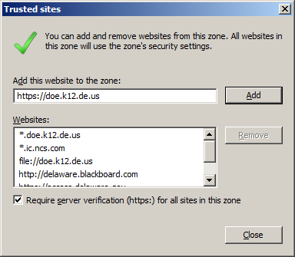

1. Click **Close**
2. Click **OK**
3. Now try to access PDMS.