[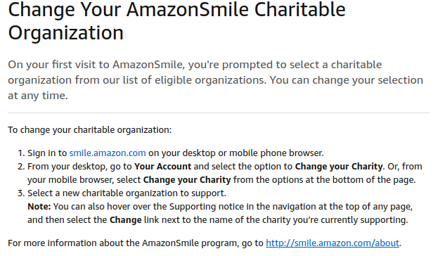](https://smile.amazon.com/)

**\*\*\*\*\*\*\*\* Search for “West Park Place Elementary PTA” \*\*\*\*\*\*\*\***

**Box Tops for Education is Digital! No more clipping!!!!**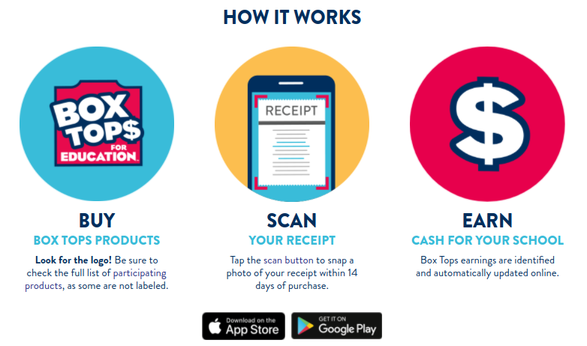

**Staples Classroom Rewards**

[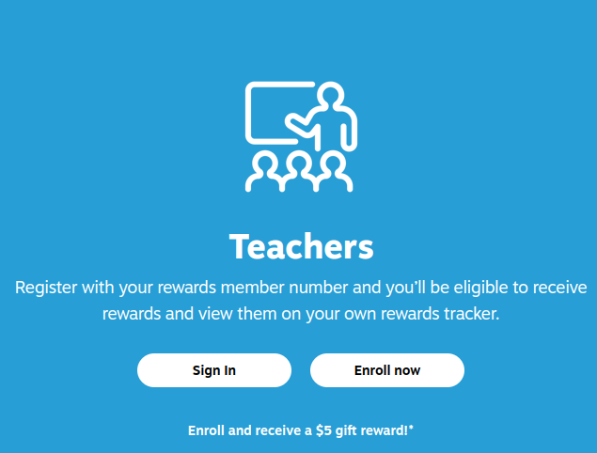](https://www.staples.com/classroomrewards/parent)